Identification of DC motor parameters
Time response

When developing a system model, we begin by using the techniques we have learned so far to build a transfer function or state space equations based on the system’s physics. The model will be in terms of parameters such as resistances (R), Masses (M or J),etc.

Sometimes these parameters values (numerical quantities) can be measured directly, such as the spring constant in the previous case study or the resistance of a wire. However, sometimes the system either:
- cannot be disassembled to individually inspect each parameter (e.g. – our motor);
- there is no straightforward way to design an experiment to measure a specific parameter (e.g.- the damping constants); or
- the system is so complicated we cannot even develop a model of it in the first place.

In this lab we experimentally determine the parameters of a DC Motor by examining how it responds to a step input.

Part 1: Derive the transfer function
As discussed in class the transfer function for the DC motor is:
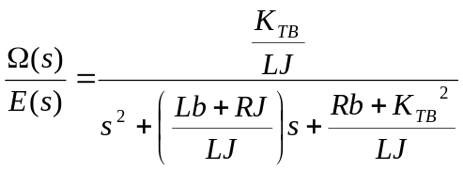

Step 1.1: We will assume the inductance and the viscous friction are negligible. Rewrite the transfer function in the box below but let L→ 0 and b→0, be sure that the leading coefficient in the denominator is 1.
(Hint: first multiply the numerator and denominator by L)

Step 1.2: Compute the DC gain, 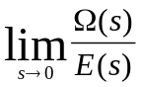,and enter it in the box below:
Kdc =

Step 1.3: Compute the pole and enter it in the box below
p=

Step 1.4: The rise time is given by 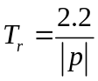enter it in the box below in terms of R, J and KTB.
Tr =

Part 2: Determining R, J and KTB experimentally

Step 2.0: Note the number on your motor:____
Check that:
- There are four wires connecting the components on your desktop.
- The Universal Power Module(large black box) is OFF. If not, the switch is on upper back.

Step 2.1: Using a multi-meter measure the resistance of your motor. Be careful! Ask your instructor to show you how to access the wires from the back if possible.
The diagram to the right shows where the resistance is measured.
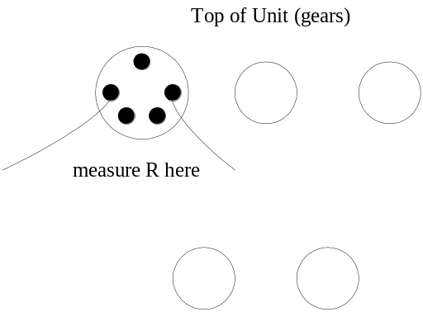Does your answer vary with the motor shaft position?
R=

Step 2.2: Copy the file DcmotTime.mdl from Black Board. Open it from within Simulink it should look like:
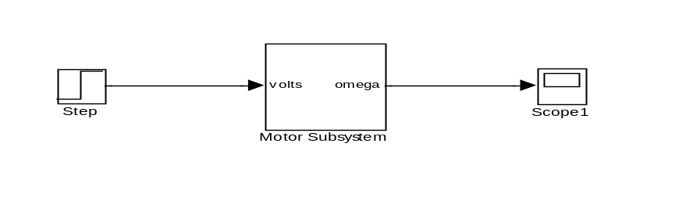
Step 2.3: Double click on the step block and set Step Time =2 (sec), Initial Value =1, Final Value = 3 (volts). Make a sketch of the input signal here. Number your axis:

Step 2.4: Turn the Power Module ON (switch: top, back). Click Wincon/Build (wait…)

Step 2.5 In the Wincon Server window click the scope icon and place a check mark next to Scope. When the Scope window pops up, go to Update/Buffer. Set the buffer to 10. Go to Axis, check Fixed and set Fixed Range from 0 to 10.

Step 2.6 Click Start. Press stop after about 5 seconds.

Step 2.7 When the experiment stops click File/Save/ Save To Workspace to import the data into Matlab. In the Matlab command window type:
>> plot(plot_time, DCmotTimeScope); hold on;
Zoom in on the transient from about 2 seconds to about 2.2 seconds.
Label the axis, give it a title and save the figure as a .fig file. This is important because you will soon plot your simulated results on the same axes. If something goes wrong you can open this .fig file and try again. Leave the figure open.

Step 2.8 Using the transient at 2 seconds, record the Steady State value and compute the DC gain. (Kdc = Steady state output/ input magnitude)

Kdc = (experimental)

Step 2.9 Compute the rise time of the second transient (time required to travel from 10% to 90% of the total change in output).
Tr = (experimental)

Step 2.10 Using the results from Step 1.2 and 2.8 Compute
KTB =

Step 2.11 Using Step 1.4, 2.1, 2.8 and 2.9 compute

J =

Part 3: Simulation

Step 3.1 In Matlab create a new Simulink file called DCmotorSim.mdl which resembles

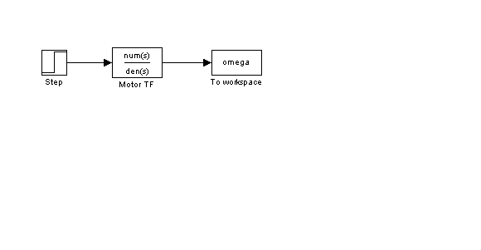

Step 3.2 Double click the step block and set the parameters to match the experiment in Step 2.3.

Step 3.3 Double click the Transfer function block and enter in the transfer function from Step 1.1, use values for R (step 2.1), J, and KTB (step 2.10).

Step 3.4 Double click the To Workspace block and set the variable name to omega. Set the save format to Array.

Step 3.5 Go to Simulation/ Configuration Parameters/ click the solver tab. Set Solver Options to “Variable Step” and “ODE45 (Dormand-Prince)”. Under Data Import/ Export, uncheck the box that says “Limit data points to last 1000”.

Step 3.6 Be sure the boxes at the top center of your Simulink screen say “Normal” (vice “External”) and “10” (vice “inf”)

Step 3.7 Click play. In the Matlab Command Window type
>> hold on; plot(tout, omega,'r--')
Save this figure. Make sure this simulated response plots over the experimental response on the same figure. Label the curves.

Part 4: Validation of the model
Step 4.1 Compute the rise time and DC gain of your simulation. Does it match your earlier experimental values? How do the overall shapes match up? Fill in the first line of the table.

Final voltage | Rise Time  (exp) | Rise Time  (sim) | % error | DC gain  (exp) | DC gain  (sim) | % error
3
5

Note: % error is 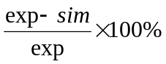
Step 4.2 Rerun your simulation and experiment for final input voltages of 5V. Note that for the experiment it is not necessary to re-“build”. For each voltage make plots of the experimental and simulated motor speeds overlaid. Fill in the remaining line of the table.

Part 5: Open loop control

Step 5.1 Using the information you have discovered so far, compute what voltage would be required to turn the motor at 7 rad/sec?

Step 5.2 Try your voltage on the hardware. How close did you come to 7 rad/sec? Print a plot of the motor’s response.

Step 5.3 Use your formula to compute the voltage to run the motor at 40 rad/sec. Try your voltage on the hardware. How close did you come? Why? Print a plot of the motor’s response.

Report:

Your report should be in memorandum format and should at the very least address the following:
- What numbers did you get for the motor parameters? Include them in the results section.
- Explain the idea behind how they were calculated.
- You might want to staple this handout to your report as an enclosure if it contains calculations. Also, include the plot from Step 2.7
- What assumptions were made about the motor’s operation?
- Discuss the Simulation vs. Experiment figure from Step 3.6.
- Why do you think we used the second transient to compute the rise time?
- Discuss the table from part 4.
- Think about part 5, give a general formula for computing what the input voltage should be to attain a certain speed. How close did you come to the desired speed?

